**Lab-02**

**Name of Lab**: Overview of Cisco Packet Tracer

**Theory**

Packet Tracer is a [cross-platform](https://en.wikipedia.org/wiki/Cross-platform) visual [simulation](https://en.wikipedia.org/wiki/Simulation) tool designed by [Cisco Systems](https://en.wikipedia.org/wiki/Cisco_Systems) that allows users to create [network topologies](https://en.wikipedia.org/wiki/Network_topologies) and imitate modern [computer networks](https://en.wikipedia.org/wiki/Computer_networks). The software allows users to simulate the configuration of Cisco routers and switches using a simulated command line interface. Packet Tracer makes use of a [drag and drop](https://en.wikipedia.org/wiki/Drag_and_drop) user interface, allowing users to add and remove simulated network devices as they see fit.

**Components in Cisco Packet Tracer**

* The work environment. The working environment is the most important component of the Cisco Packet Tracer.
* Main Menu. On the top, you'll find a menu bar just like other software packages. ...
* Toolbar.
* The Canvas a.k.a. Drawing Area.
* Toolbox.
* Side Menu.
* Realtime Evaluation Results Bar

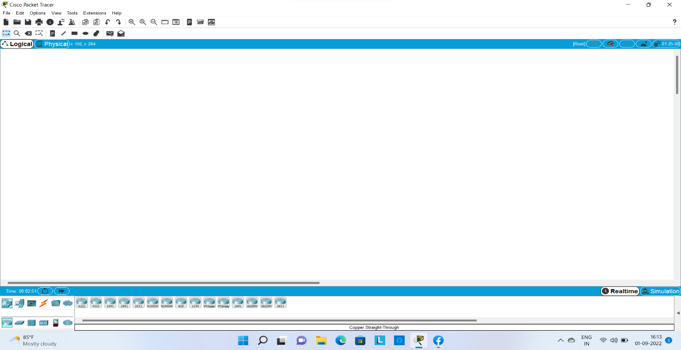

**Network devices:**

Hardware devices that are used to connect computers, printers, fax machines and other electronic devices to a network are called network devices. These devices transfer data in a fast, secure and correct way over same or different networks. Network devices may be inter-network or intra-network.

# Example: Hub, Repeater, Bridge, Switch, Router, Gateways and B-router

**End devices**

A source or destination device in a networked system.

Example: PC, Laptop, Server etc

**Connections :**

These are the wire used in connection between various devices.

Example : straight through wire, cross over wire etc.

* Miscellaneous
* Multiuser connection

**Views of Cisco Packet Tracer**

* Real time view
* Simulation view

**Real time view:**

In real-time mode the network behaves as real devices do, with immediate real-time response for all network activities. The real-time mode gives students a viable alternative to real equipment and allows them to gain configuration practice before working with real equipment.

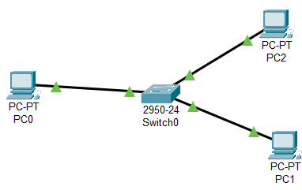

**Simulation view:**

In this view we see actual movement of packet between the devices.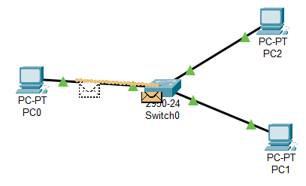

**Conclusion:**

In this lab, we got familiar with the cisco packet tracer how we can use to learn various topic of computer network work.